Physics: 1. Units and Measurement
Please remember to photocopy 4 pages onto one sheet by going A3→A4 and using back to back on the photocopier

Syllabus
OP1 Measure length, mass, time and temperature (SI units); perform simple calculations based on these to find the derived quantities: area and volume.
Perform simple calculations based on speed and velocity.
Understand that units of measurement follow the SI system.

OP2 Measure mass and volume of a variety of solids and liquids.

Student Notes

Measurement: some commonly-used instruments
Metre Stick | Thermometer | Graduated cylinder
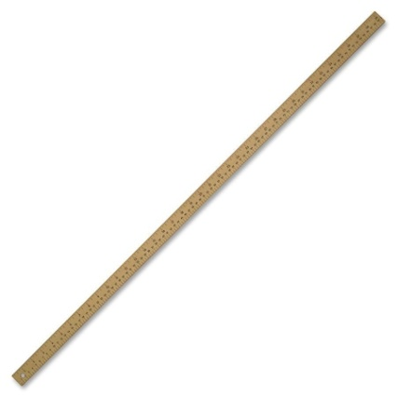 | 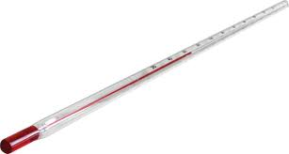
A meter stick is used to measure the length of an object | A thermometer is used to measure temperature | A graduated cylinder is used to measure the volume of a liquid
We measured the length of  ______________________  The length was ________ grams | We measured the temperature of ___________________________  The temperature was _______ ⁰C | We poured water into the graduated cylinder.  The volume was ________ ml

Callipers | Newton-meter | Electronic balance
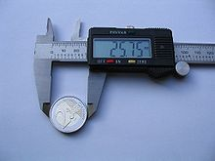 | 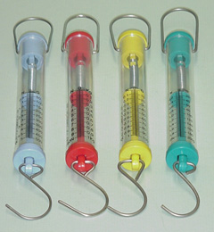 | 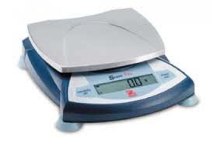
A callipers is used to measure the diameter of a cylinder or wire | A newton-meter is used to measure force (or weight) | An electronic balance is used to measure the mass of an object
We measured the diameter of ________________________  The diameter was _________ mm | We measured the weight of ____________________  The weight was ___________ N | We measured the mass of  ______________________  The mass was __________ grams

Question: What do you call a cylinder that went to college?
Answer: A graduated cylinder. Boom Boom!
What is mass and what is weight?
We will study both of these in detail in a later chapter so don’t worry if you don’t know what they are. For now you just need to be able so say how they are measured and what the units are for each.
This happens a lot in Science – we don’t want to throw everything at you at once, but sometimes we will mention ideas that will only make sense at a later stage (unless of course you wanted to study them yourself).

Units
There are many different units for some quantities like length and mass.
How different units of length can you think of?
It is important for scientists that everybody is using the same units.
Can you say why?

Scientists use units called S.I. Units
S.I. stands for Système International d'unités ; it is in French because it was the French who first promoted this system (you don’t need to know this).
What do you think Système International d'unités means ?

Summary of scientific units and commonly-used equipment
 | Length | Mass | Time | Temperature | Area | Volume | Speed
S.I. units | metres | Kilograms | seconds | Degrees Celsius | Metres squared | Metres cubed | metres per second
Symbol | m | kg | s | ⁰C | m² | m³ | m/s
Equipment | Metre stick | Electronic balance | Clock, stopwatch | Thermometer

Speed and Velocity

Speed = distance ÷ by time
The unit of speed is the metre per second (m/s or m s⁻¹)

$$Speed=\frac{distance travelled}{time taken}$$

Velocity
Velocity is much the same as speed, except when we talk about velocity we usually include a direction, e.g. the velocity of a car is 10 m/s due East.

Velocity is the same as speed in a given direction

Area and Volume

Area of a regular object = length × width

Volume of a regular object = length × width × height

Burette
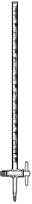

Instruments used to measure the volume of a liquid
- Graduated cylinder
- Burette

Other commonly-used units:
Mass: grams (g)
Area: centimetres squared (cm²)
Volume: centimetres cubed (cm³)
1 litre = 1000 cm³

Experiments:
Measure mass and volume of a variety of solids and liquids.
- To measure the density of a regularly-shaped block
- To measure the density of an irregularly-shaped small stone
- To measure the density of an irregularly-shaped large stone
- To measure the density of a liquid
Summary of all the experiments

To find the mass and volume of a regularly-shaped block
To find the mass - weigh it on an electronic balance.

To find the volume:
Volume = length × width × height
In this case the volume is 5 × 2 × 1 = 10 cm³.

To find the mass and volume of an irregularly-shaped small stone
To find the mass - weigh it on an electronic balance.

To find the volume:
Drop the stone into a graduated cylinder containing water and note the new volume.
To get the volume of the stone simply subtract the two readings.
In this case the volume = 90 – 75 = 15 cm³.

To find the mass and volume of an irregularly-shaped large stone
To find the mass - weigh it on an electronic balance.

To find the volume:
Fill an overflow can up to the top and place an empty graduated cylinder under the spout.
Carefully drop the stone in (using a string so there is no splash).
Note the level of water in the overflow can.

To find the mass and volume of a liquid
To find the mass:
Weigh an empty graduated cylinder, and then weigh the graduated cylinder after pouring water into it.
Then subtract the two readings.

To find the volume simply note the level of water in the graduated cylinder.
Exam Questions: Measurement and Units
m
kg
s
- [2010 OL]
- Which of the following is the unit used to measure mass?
- Which of the following is the unit used to measure time?

- [2008 OL]
Name and give one use for the piece of equipment shown in the diagram.

- [2008 OL][2006 OL]
- Name the piece of equipment drawn on the right.
- Give one use for this piece of equipment.

- [2012 OL]
The picture shows a piece of equipment used in the laboratory for measurement.
- Name the piece of equipment shown.
- What is it used to measure?

- [2009]
Name any two items of laboratory equipment shown in the diagram on the right.

- [2007 OL] [2007]
- What is the name the piece of equipment shown on the right?
- Name a second item of laboratory equipment which enables more accurate measurements of volume to be made.

Speed and Velocity
- [2009]
Define velocity.

- [2007 OL]
The speed of a car is 15 m s^{–1}.
What distance will the car travel in 5 seconds?
What word describes what happens when the speed of a car increases?

- [2009 OL]
A cyclist moves 20 metres along a track in 4 seconds.
Calculate the speed of the cyclist.
Calculate the distance the cyclist will travel in 2 seconds.

Area and Volume
- [2006 OL][2012 OL]
Find the area of the rectangle drawn on the right using the measurements given.
In what unit is the area measured?

- [2007 OL]
A block of metal has the measurements shown on the right.
Calculate the volume of the block.

- [2011 OL][2009 OL][2006 OL]
  - The diagram shows a piece of equipment, labelled A, containing water.
Name A.
  - A stone was then added and a new volume was recorded as shown in B.
What was the volume of the stone in cm³?

- [2009]
A pupil measured the volume of a potato using the items of laboratory equipment, labelled A and B as shown in the diagram.
- Name the items labelled A and B.
- What was the volume of the stone in cm³?

- [2008]
- Give one safety precaution taken by the pupil, shown in the photograph, while doing an experiment in a school laboratory.
- Describe a precaution, not shown in the photograph that you would take when heating a substance in a test tube in a school laboratory.

Exam Solutions

- kg
- s
- 6 × 4 = 24 cm²
- 5 × 2 × 1 = 10 cm³
- Thermometer; it is used to measure temperature

- Tripod
- To hold (support) objects (when heating)

- Electronic balance.
- To measure the mass of the object
- Bunsen burner/ tripod/ pipe clay triangle/ crucible/ tubing/ evaporating dish
- Graduated cylinder
Pipette/burette
- Graduated cylinder
15 cm³

- Item A is an overflow can
Item B is a graduated cylinder
- Volume is 125 cm³

- Wearing goggles/ looking through wall (side) of test tube/ tube in holder/ apparatus in centre of bench
- Point tube away/ add boiling chips to a liquid/ use small amounts/ lab coat/ heat gently/ screen/ gloves/ tie hair back…

Teaching Measurement and Units
Syllabus
OP1
Measure length, mass, time and temperature, and perform simple calculations based on these to find the derived quantities: area, volume, density.
Understand that units of measurement follow the SI system.

OP2
Measure mass and volume of a variety of solids and liquids and hence determine their densities.
OP1:
Measure length, mass, time and temperature and perform simple calculations based on these to find the derived quantities: area, volume.
Understand that units of measurement follow the SI system.

  - Measure length, mass, time and temperature
Straightforward, but ideally you will need to create the table for them and mention the units without going onto why you use these units.

  - Perform simple calculations based on these to find the derived quantities: area and volume
See examples in the text-book. Alert students that they will be doing experiments to find actual areas and volumes once they can demonstrate that they understand the concepts.

  - Understand that units of measurement follow the SI system
Ask students how tall and heavy they are and 90% will give a values in ft and ins and stones and pounds, not withstanding that some of them do not know the number of inches in a foot and many do not know the number of pounds in a stone.
Remember the ruckus caused by Irish drivers having to know their speed in kilometres per hour, when they were used to miles per hour?
Or the currency conversion from punts to euro?
Why do you think we need one standard?
Can you think of different units to measure mass, length or speed?

Table of some physical quantities and S.I. units
The Standard Internationale or (S.I. for short) is now regarded as being the international standard for scientists (the French came up with the idea).
 | Length | Mass | Time | Temperature | Area | Volume | Speed
S.I. units | metres | Kilograms | seconds | Degrees Celsius | Metres squared | Metres cubed | metres per second
 | m | kg | s | ⁰C | m² | m³ | m/s

- The unit of length is the metre
Note that millimetres, centimetres and kilometres are not different units, but multiples of the metre, which is the standard. Quite often we will measure length in centimetres (cm) instead of metres. This is still okay, because we know that there are 100 cm in a metre and can convert back from one to the other whenever we need to. However it is very important that we include the unit (i.e. cm or m) after each measurement so that we know whether they represent centimetres or metres (or apples or bananas!)

Of course the next problem was to make sure that a metre in France was the same length as a metre in Ireland.
Now that’s not too bad.
All you need to do is go to France and cut a piece of string (or timber) the same length as the French metre and then bring it back to Ireland where it can be used ‘to set the standard’.
But it’s a bit trickier than that.
It turns out that objects expand when they get hot, so the string would actually get longer when the weather got hot, or could absorb moisture and expand, or could get frayed at the edges and smaller.
So you see it can be a very difficult job to maintain a standard for any quantity.
- The unit of time is the second
You can’t just take a second and stick it in your pocket.
Maybe if you have a digital watch you could do it, but back 300 years ago when people were first trying to standardise time, there were not even any accurate clocks, let alone watches. So how did they decide on what a second was?
One of the most popular methods was to use a pendulum; the length of time a pendulum took to make one full oscillation depended on its length, so all they had to do was get a length which gave a period of one second and keep that. What problems do you think they might have come across?

- The unit of mass is the kilogram and can be measured using an electronic balance
Did you know that in Paris they actually have a lump of metal which is exactly one kilogram, and that this has been used as the standard for over two hundred years?
Why does this seem hard to believe?

- The unit of volume is the metre cubed (or centimetre cubed)
The volume of a liquid is measured using a graduated cylinder.
The volume of a regular solid is calculated by multiplying length × width × height.
The volume of a large irregular solid is calculated by using an overflow can.

OP2:
Measure mass and volume of a variety of solids and liquids.

Do NOT bother with teaching how to use a vernier scales; it is not necessary and can be a nightmare to teach.
They should however be able to use and identify the other common instruments.

Students can measure and record their mass, height, arm length, thumb width etc directly in SI.
A nice variation is to divide the circumference of a number of different circles by their radius to obtain an approximation for pi (3.14). Hopefully this will pique the curiosity of some of them. It’s interesting to note that this number crops up in all different areas of Science, and seems to be one of its fundamental mathematical building blocks.

Then they move on to calculating the area and volume of their text-book, lab bench and classroom.
Finally they tackle the more formal experiment (which is necessary for knowing how to measure density later on in the course):

Method
Mass of wooden block
Volume of wooden block
Mass of irregular stone
Volume of irregular stone
Mass of liquid
Volume of liquid

